BATTLE OF THE YUNNAN

**Introduction** **3**

[**Important concepts**](https://docs.google.com/document/d/135ISCGl9AyqPXWdjuXWMRsC18BKo0X4guizSJkUcvYM/edit#heading=h.fsevs0yj2f31)[**4**](https://docs.google.com/document/d/135ISCGl9AyqPXWdjuXWMRsC18BKo0X4guizSJkUcvYM/edit#heading=h.fsevs0yj2f31)

Agent 6

Environment 6

State 6

Action 7

Reward 7

Policy 7

Value function 8

Value based algorithms 8

Q-learning 8

Q learning process 10

Sample Calculation 11

[SARSA](https://docs.google.com/document/d/135ISCGl9AyqPXWdjuXWMRsC18BKo0X4guizSJkUcvYM/edit#heading=h.bj081n2l8ptc) [12](https://docs.google.com/document/d/135ISCGl9AyqPXWdjuXWMRsC18BKo0X4guizSJkUcvYM/edit#heading=h.bj081n2l8ptc)

[**Guide for the Game**](https://docs.google.com/document/d/135ISCGl9AyqPXWdjuXWMRsC18BKo0X4guizSJkUcvYM/edit#heading=h.4d5kgwz1iprj)[**13**](https://docs.google.com/document/d/135ISCGl9AyqPXWdjuXWMRsC18BKo0X4guizSJkUcvYM/edit#heading=h.4d5kgwz1iprj)

The Map 13

What does it take to win? 14

How many lives does your agent have? 14

How can you collect points? 14

Actions 15

Items in the game 15

**Setup Guide** **17**

Download required software 17

Download VSCode 17

Download the installation package 17

Setting up a virtual local environment 18

Windows 18

A. Permissions 18

B. Installing and setting up the background 19

C. Installing the package 22

Mac 23

A. Check if Python is installed on Mac 23

B. Set up the virtual environment 24

[30](https://docs.google.com/document/d/1WfBou057Iy0AheEWgsEDefpJQecHkrr12sJGTigegCc/edit#heading=h.61npbvz1r9a7)

# Introduction

Years of peace and friendship between monkeys and boars in NTU have now ended!

Humans plan to clear ⅔ of forest lands in NTU for new construction projects. This means that not all species can live here. Some must move out to the Jurong Zoo. The question is which one? The two great wild species monkeys and boars have built a civilization here. The boars claim ownership of their land through their ancestors. As claimed by the boars, Pioneer was a boar heaven before humans constructed the university. On the contrary, monkeys disapprove of their claim as propaganda. They claim ownership of Pioneer University by their numbers. Apparently, monkeys are 63.47% of animals(more than 40 cm in height and not including humans) in NTU. Boars are only 23.23%. Peace and harmony are not possible. The tensions have amassed to an all-time high. At the same time giving up is not an option. There is no honor in giving up your home and walking to Jurong zoo where food is not enough and not yummy. War is certain! But not that kind of war. The president of Monkeys, and Queen Boar have made a negotiation to decide ownership of the land with the Battle of Yunnan 2022, designed by MLDA’s Team Delichon. Winner stays. Losers are shipped to Jurong Zoo. Both parties agreed to battle next weekend. And they are now looking for your help to train them.

**You chose Team Boar**

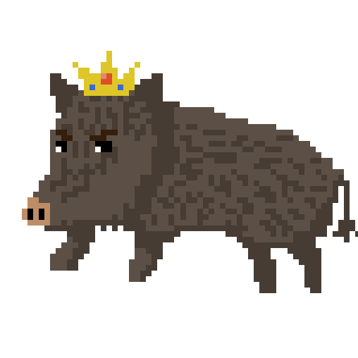

Hi I’m Queen Boar. I’m highly delighted that you chose our side. The true side. The ever reigning side. We have a long history of boar kings and queens that ruled this place. Pioneer was and is our land. It’s our forefathers’. It’s our pride. We cannot let go of it, simply because of some pests(apes). We boars will defeat these apes and send them to the place they deserve. Go through this guide and learn the magic spells of reinforcement learning. This will help us in our battle.

# Important concepts

**What is Reinforcement Learning ?**

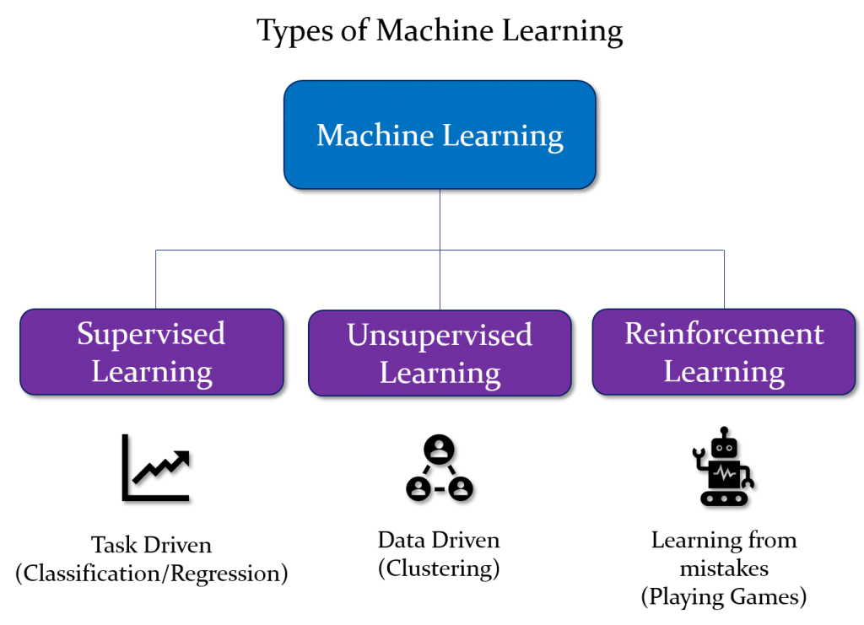

Reinforcement learning is a special branch of machine learning. If you do not know what machine learning is, it’s basically a way to make computers smart enough to make decisions for themselves by using special algorithms and data. To do machine learning, you have to teach a computer about wrong and right decisions. This is called training. When trained, computers can make quite accurate decisions. There are various types of machine learning methods available. Reinforcement Learning is one of them, and it’s the focus of this competition. What is so special about Reinforcement learning? What makes it so different from others? These are questions which I will answer, but you must first understand the concept with an example.

| Classification of machine learning | Description |
| --- | --- |
| Supervised learning | Teaching a child the differences between a dog and cat by showing labeled pictures of cats and dogs. The child will learn to differentiate between dogs and children.  Real life examples :   1. Spam emails detection 2. Sentiment Analysis |
| Unsupervised learning | This type of learning makes use of the pattern-recognizing ability of machines in identifying structures and trends in data. In this example, data is unlabelled.  Real life examples   1. Facial recognition. Your camera detects features and patterns on your face by looking at multiple photos 2. Genetics, for example clustering DNA patterns to analyze evolutionary biology. |
| Reinforcement learning | In this example, the data that the machine receives to analyze is highly dependent on the previous action implemented by the machine. Therefore, machines learn how to control data by implementing actions that maximize a certain goal.   1. Self-driving cars |

Imagine if you find yourself on an elephant and you are supposed to use it to go back home. This is tough. You may have ridden a horse before, but an elephant is different. It’s much bigger, rounder, slower. It also has a different temperament that you do not know of. Maybe it’s more impatient than a horse. Unfortunately, there is no one around to help you. How would you then find your way?

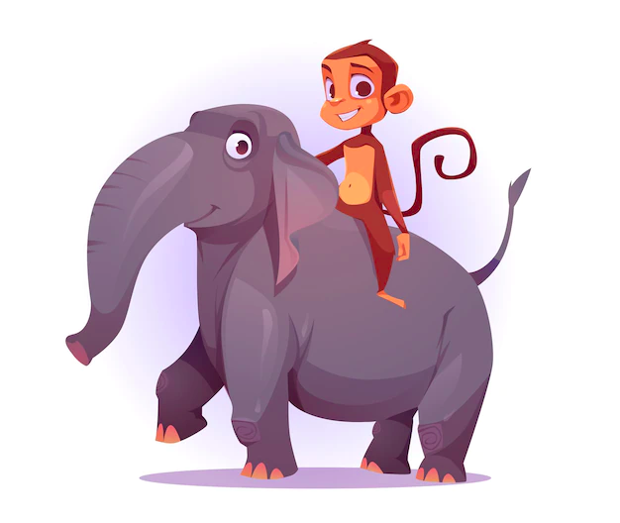

<https://thompsonandredwood.com.au/the-difference-between-elephant-training-and-horse-training>

The only way for you would be to experiment (this is HIGHLY dangerous and we do not recommend it). You would try different actions. For instance, shouting, rubbing its back, tapping your feet. *“You will simply try everything you possibly can.”* Maybe even sing a love song to flirt with the beast. This is what we call **exploration**. Each action may bring some change. If the elephant moves, then your position changes. Hence, each action helps you transition into a new **state**. While exploring, you would also constantly observe if the elephant responds to any of your actions. The responses can be either **positive** or **negative**. Maybe the elephant will start moving majestically to your house. Or maybe, it will get frustrated and drop you into a pond! Either way, these responses signal you about the system. Let's call these signals rewards.

You will continue to explore and **remember** what actions gave what **rewards.** With experience you will **learn** the best actions for controlling your elephant. You will continue to **exploit**  those actions. Now that you have got control of your elephant’s motion, you will take it in the direction of your home. Eventually, you will have mastered taking the elephant.

This is precisely what reinforcement learning is. Notice that you learned how to ride this elephant. You figured it out yourself. Isn’t this wonderful? If you can learn how to ride an elephant, you can do anything. You can learn how to cook pasta, paint. (Warning: Too much optimism can be dangerous.). This method of depending on experience to learn is precisely how you learned how to walk, how to ride a cycle, how to behave in a social environment. Can you remember such cases of reinforcement learning? How did you explore?This is great! But what scientists and programmers today are interested in is whether this behavior can be replicated in computers. This can make computers powerful. They can learn so many things. It’s also what you are going to do in this competition. You are going to teach your monkey to win the Battle of Yunnan using reinforcement learning by this week.

A computer is perfect for reinforcement learning. It’s equipped with great processing ability which allows it to do computations faster than humans. So it can do these explorations very fast. It doesn’t need any breaks and is consistent in performance. To tap this ability of a computer, we write a piece of program that empowers an agent to do this. This code is stored in a file called agent.

Lets understand the process of Reinforcement Learning a little bit more theoretically. The following diagram best summarizes the concept.

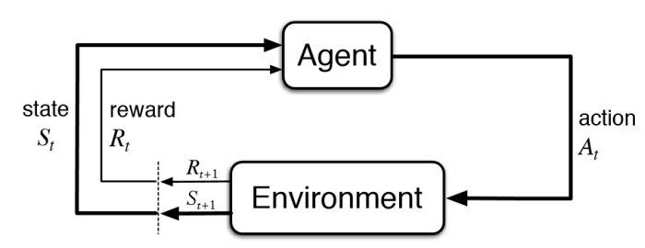

The above diagram is the most important concept in RL. Understanding this can give you clarity about what RL is and what is your role in the competition. Therefore, let’s define the terms that have been used in the diagram. After that we will learn how they are all connected.

## Agent

An agent is a program, a piece of code, that implements actions based on the rewards it receives.

## Environment

The entire virtual world that the agent interacts with. The environment is what the agent interacts with, the world through which it moves. It is not static. It changes either due to the agent’s actions or some other random feature.

## State

States are the observations that the agent makes while it is in the environment. A state can also be looked at as the immediate situation in which the agent finds itself in. Suppose you’re watching a movie, a single frame would be a “state.” In reinforcement learning a specific instance of the environment is called the state.

## Action

This is pretty self-explanatory. Action is the move that the agent takes. An agent usually chooses from a list of discrete possible actions. In video games, the list might include running right or left, jumping high or low, crouching or standing still. In the stock markets, the list might include buying, selling or holding any one of an array of securities and their derivatives. When handling aerial drones, alternatives would include many different velocities and accelerations in 3D space.

## Reward

A reward is the feedback by which we measure the success or failure of an agent’s actions in a given state. It’s like giving sweets to the agents for performing good actions. Rewards can be positive or negative. In the elephant example, if it reaches a location that is closer to the destination, it will receive a positive reward. If the elephant falls into a pond it will receive a negative reward.

## How are they all connected?

Well now that you have understood the main elements that exist in a RL model, you are ready to learn how they all interconnect with each other…

In any kind of RL problem, we want our agent to excel at some task. This task can be anything. For example, driving a car, playing Super Mario, etc. Unfortunately, we cannot tell our agent directly to do something. To give a sense of task to the agent, we assign rewards for every state it receives from the environment. In a particular state, an agent can receive a very high reward, negative reward or low reward. The end goal of an agent is to carry out tasks in order to maximize the total cumulative reward it receives. To do this, the agent first explores all the possible moves it can make in every action, and generates an output value.

## Value function

After a long day of work, suppose you are given two choices: go out with your friends for a drink or go back home and finish a long pending coding project. If you choose to hang out with friends, your friends will make you feel happy; whereas heading home to finish your project, you’ll end up feeling tired after a long day at work. In this example, enjoying yourself is a reward and feeling tired is viewed as a negative reward, so why do the project?

Because in life, we don’t just think about immediate rewards; we plan a course of actions to determine the possible future rewards that may follow. Perhaps working on the project will help you build your skills and may brush up your understanding of a particular topic really well, get recognised and ultimately land you that dream job you’ve always wanted. In this scenario, getting your dream job is a delayed reward from a list of actions you took, then we want to assign some value for being at those states (for example “going home and finishing the project”). In order to determine the value of a state, we call this the “value function”.

## Policy

You can think of policy as a strategy that the agent uses in order to achieve its goal. In our case, it is the strategy of the monkey or boar warrior to ensure that they claim victory on Yunnan Gardens. In the case of our elephant friend, a policy would be a strategy it devices to take you to your destination.

## Value based algorithms

In value-based RL, the objective is to optimize a value function, a function (can be thought of as a simple Lookup table) which maps maximum future reward to a given state. The value of each state is the total amount of reward an RL agent can expect to receive until the fulfillment of goal.

### Q-learning

Q-Learning is one of the strategies or algorithms that we will be teaching you that the agent can use to achieve its goal.

Q-Learning is a value-based learning algorithm. It is used to learn the quality of actions and telling the agent what action is to be taken under which circumstance. The objective of the Q Learning algorithm is to optimize a value function suited to a given problem/environment.

The ‘Q’ stands for quality; it helps in finding the next action resulting in a state of the highest quality. The values are stored in a table, called a Q Table.

Let us devise a simple 2D game environment of size 4 x 4 and understand how Q- Learning can be used to arrive at the best solution.

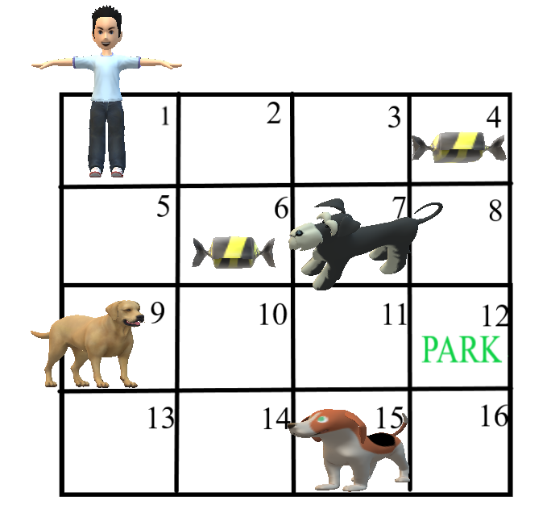

**Goal:** In this scenario, the goal of the kid to get to the park.

**End of an Episode:**

A. Encounter Dog

B. Reach Park

**Reward System**:

Considering the goals, we would give rewards to the kid.

A. Get candy = +10 points : When the kid eats the candy, it becomes faster and finishes in less time. Therefore, we will assign it a positive reward. But not so positive, because it’s not the end goal.

B. Encounter Dog = -50 points : This is game over. This is a bad outcome for the kid. Therefore, we will assign it a very negative reward.

C. Reach Park = +50 points : By reaching the park, the kid has won. It should be highly rewarded.

Great, we have assigned all the rewards that we have for our agent. Now let us see how a typical Q learning agent will play this game using the rewards that we have just assigned. First, let us create a Q- table where we will keep a track of all values associated with each state.Q-table stores the **value created upon executing an action in a particular state.** The Q Table will have rows equal to the number of states in the problem i.e. 16 in our case, and the number of columns would be equal to the number of actions an agent can make which happens to be 4 (Up, Down, Left & Right).

| ACTIONS  STATES | UP | DOWN | LEFT | RIGHT |
| --- | --- | --- | --- | --- |
| 1 (START) | 0 | 0 | 0 | 0 |
| 2 | 0 | 0 | 0 | 0 |
| …… | 0 | 0 | 0 | 0 |
| 16 | 0 | 0 | 0 | 0 |

Sample Q-Table for 4 x 4 2D game environment

#### Q learning process

1. **Initialization**

When the agent plays the game for the first time, it has no prior knowledge so let’s initialize the table with random values between 0 and 0.5

1. **Exploration vs Exploitation**

Now the agent can interact with the environment in two ways: either it can use already gained info from the Q-table i.e. exploit, or it can venture to uncharted territories i.e. explore. Exploitation becomes very useful when the agent has worked out a high number of episodes and has information about the environment. Whereas, the exploration becomes important when the agent is naïve and does not have much experience. This tradeoff between exploitation and exploration can be handled by including epsilon in the value function. Ideally, at initial stages, we would like to give more preference to exploration, while in the later stages exploitation would be more useful.

In Step 2, the agent takes an action (exploit or explore).

1. **Measure reward**

After the agent performs an action decided in step 2, it reaches the next state say s’. Now again at state s’ the four actions can be performed, each one leading to a different reward score.

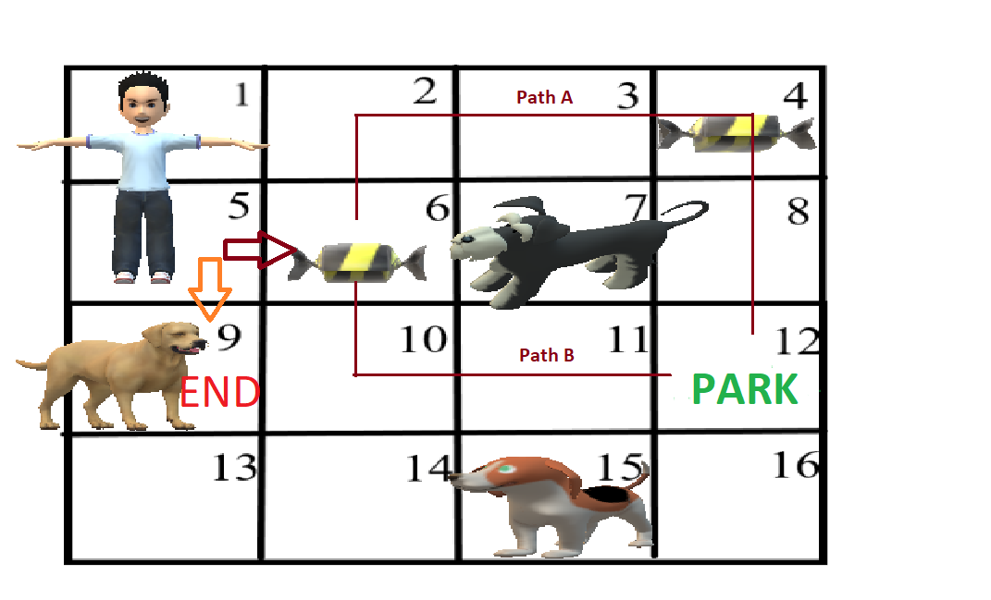

Scenarios when agent moves to state 5

For e.g, the boy moves from 1 to 5, now either 6 can be selected or 9 can be selected. Now for finding the reward value for state 5, we will find out the reward values of all the future states i.e, 6 & 9, and select the maximum value.

At 5, there are two options (For simplicity retracing steps is not performed)–

1. Go to 9 : End of Episode
2. Go to 6 : At state 6 there are again 3 options –
3. Go to 7 – End of Episode
4. Go to 2 – Continue this step until reach end of episode and find out the reward
5. Go to 10 – Continue this step, find out reward

#### **Sample Calculation**

Path A reward = 10 + 50 = 60

Path B reward = 50

Max Reward = 60 (Path A)

Total Rewards at State 5: -50 (Faced dog at 9), 10 + 60 (Max reward from State 6 onwards)

Value of reward at 5 = Max (-50 , 10+60 ) = 70

**4. Update the Q Table**

The reward value calculated in step 3 is then used to update the value at state 5 using the Bellman’s equation-

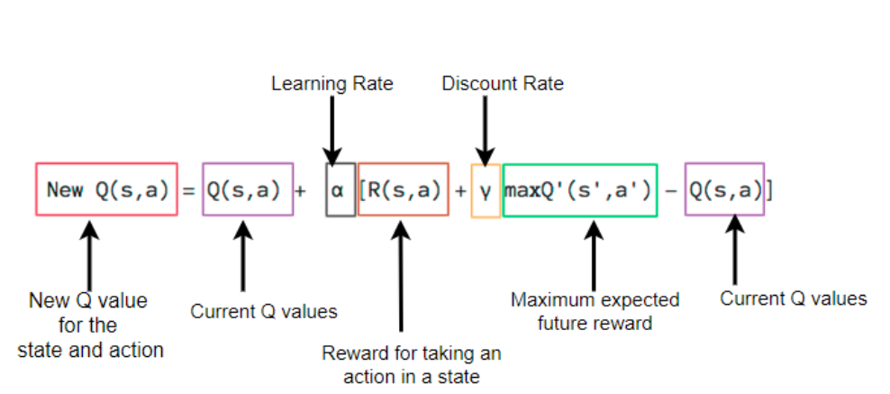

Here, **Learning rate** = A constant which determines how much weightage you want to give to the new value vs the old value.

**Discount Rate =** Constant that discounts the effect of future rewards (0.8 to 0.99), i.e., balance the effect of future rewards in the new values.

The agent will iterate over these steps and achieve a Q- Table with updated values. Now using this Q-Table is as simple as using a map, for each state select an action, which leads to a state with the maximum Q value. Awesome! We have understood Q-Learning. Now we will learn about the environment that we will have.

# Guide for the Game

Battle of the Yunnan is inspired by the famous game Bomberman (aka Pommerman/ Bomberland). The game involves 2 players spawning on a 2D map and trying to kill each other with the use of exploding bombs.

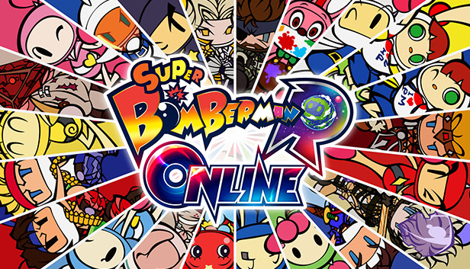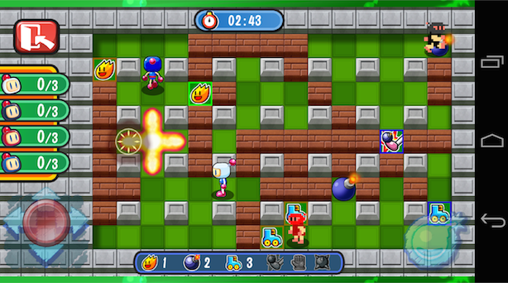

This game is usually played by humans. But we at MLDA, designed a game environment for you which can allow reinforcement learning for your agents. We didn’t create this ourselves. It’s built on top of a game built by **coderone dungeons and data structure.**

We hope that you train your warrior agent (monkey or boar) to win this game. The following guide helps you understand the game.

## The Map

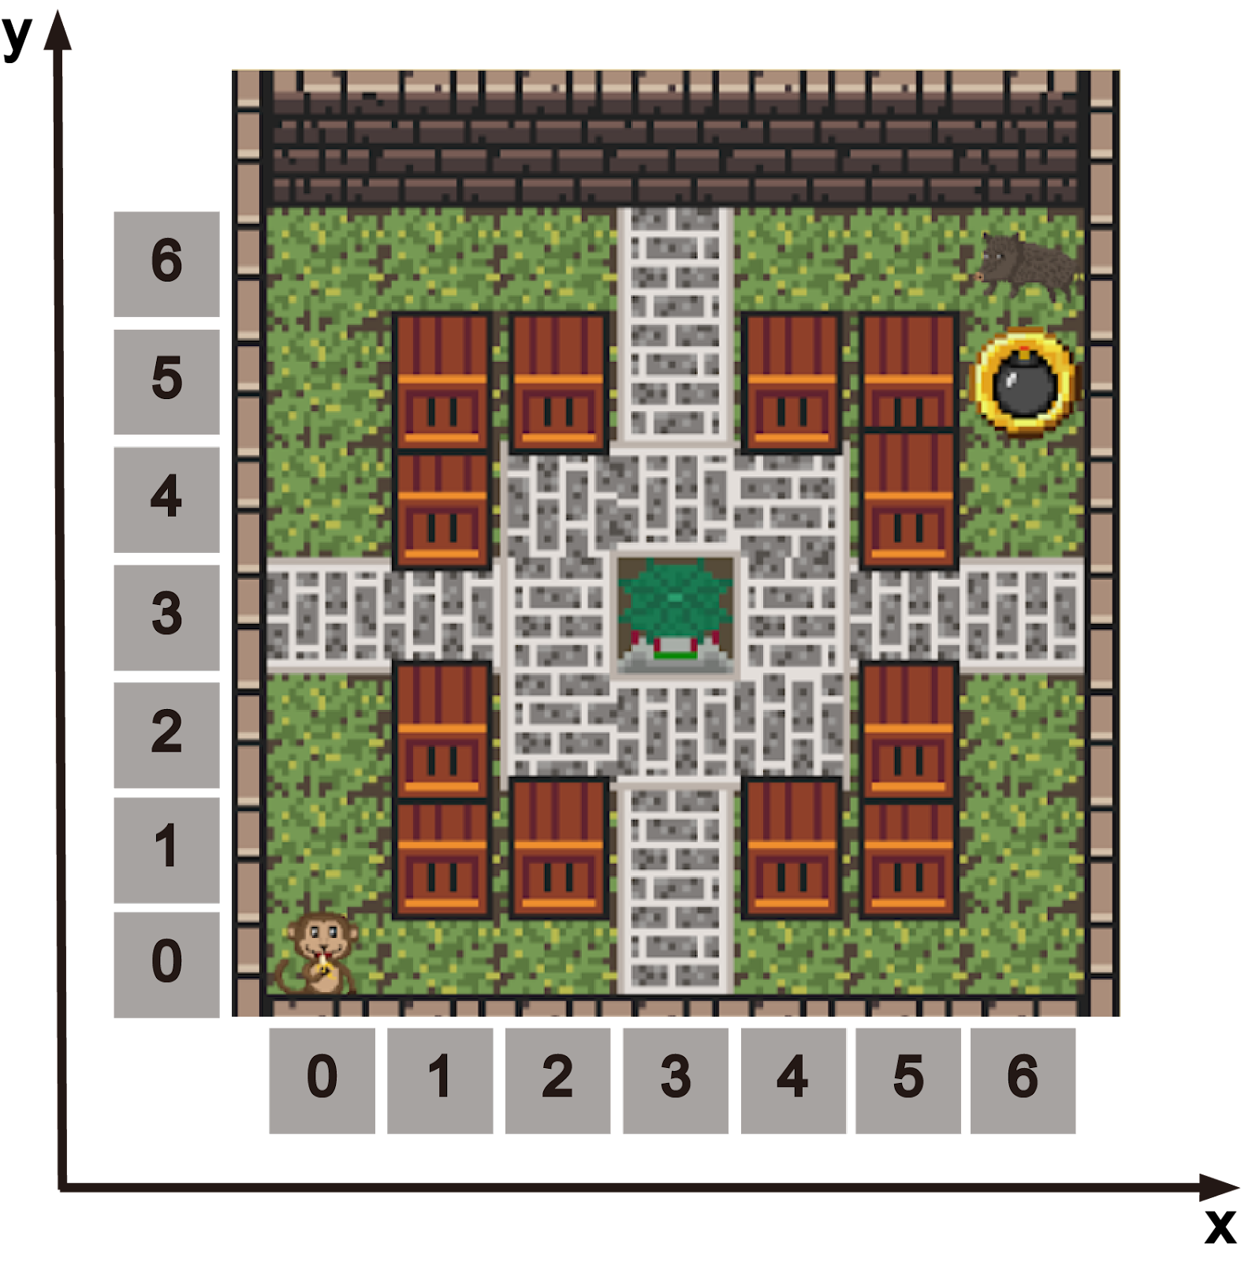

The game is played on a 7x7 grid. The theme is based on the beautiful Yunnan Gardens located at NTU. The map shows the coordinate system of the game. The working of the game is simple. The game runs for 1800 ticks. At each tick, the game sends the environment data to both the agents and asks them to submit a move. The game then implements these moves and computes its effect to implement changes in the environment and rewards of the agents. During the 1800 tick, the game will also spawn ammo at random locations for agents to collect.

## What does it take to win?

There are two ways you can win. You must be the last standing warrior (monkey or boar). To do this, you either kill the other player, or you remain alive and have the highest points at the end of 1800 ticks to claim Yunnan Gardens!

## How many lives does your agent have?

At the beginning of the game, both the monkey and boar warriors are given three health points each. These reduce, if your agent gets bombed. If your warrior loses all three Health Points, then you get shipped off to Jurong Zoo!

## How can you collect points?

One of the simplest ways to gain points is to destroy the wooden blocks placed in the battlefield. For every wooden block that you destroy your warrior gains 2 points.

Another way to ensure victory is is to bomb your opponent which will lead to them losing a Health Point and your warrior gaining 25 points!!

## Actions

Your agent can perform 6 actions: do nothing, move up, down, left, or right and place a bomb.

**[ (None) , u , d , l , r , p ]**

## Items in the game

**Wooden Block**



These are wooden blocks. They are very weak and easily explode by bombs(only 1 hit required). An agent can defend itself against an explosion by taking cover of a bomb. By destroying this block, your agent receives 2 score points.

**Wall**



This is an indestructible block that defines the boundary of the map. You cannot destroy it and escape it. Why would you do that anyway. You aren’t a coward, are you?

**Ammo**



These are spawned on the map after every few ticks. Collect them to be able to drop bombs on the enemy. There are no points earned on collecting them.

**Pavillion**

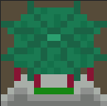

Take some time to appreciate this beautiful structure. This is the red pavilions at Yunnan Gardens. This piece of art along with most other blocks were made by our graphic designer – Teresa. If you like, please drop a “Nice Work Teresa.” The pavilion is just a show piece. There aren’t any magical potions or free health points by standing there. So don’t bother.

**Bomb**



Each warrior starts off with 3 ammo power ups. If you place a bomb, your ammo reduces by one. After the bomb is dropped, it takes 20 ticks to explode. The bomb radius is 2 tiles up, down, left, and right of where the bomb is placed.

**Agent**



# Setup Guide

## Download required software

Ready to start. First you will have to set up the environment. This can take some time. So grab a coffee and get ready.

### Download VSCode

VSCode is a code editor that can be used to code-debug-run your program. It is the most widely used tool among developers and we encourage you to use it as well! Though feel free to use any editor of your choice.

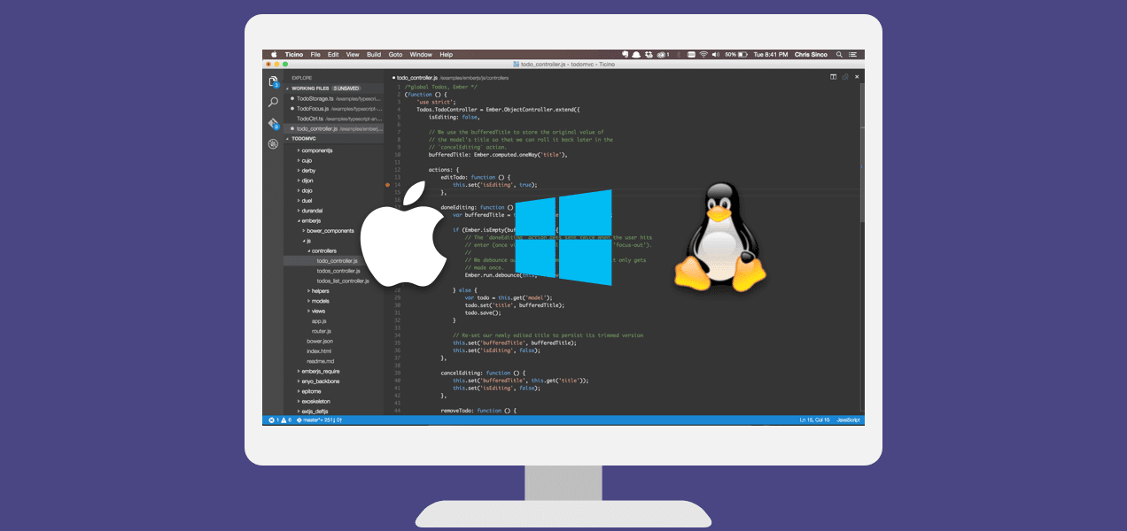

Here is a link to help Windows and Mac users download VSCode: <https://www.youtube.com/watch?v=bN6DE-4uFNo>

### **Download the installation package**

We have provided you with [**some files**](https://drive.google.com/drive/folders/1jAcrA0P0eLxnGqCFpp1by26u5wKs8qDR?usp=sharing), including the game environment, and all the agents template.. Make sure this is downloaded in the folder. This contains the code to set up the bomberman game. Feel free to open this file and go through the different folders. But do not change anything.

## Setting up a virtual local environment

Now that you have the installation package ready, you need to run it now. It turns out that the game has certain dependencies which do not match your system. Basically, our game is a little stubborn. We cannot change your computer configuration, because this might affect your other projects. So to solve this, we are going to run a local virtual environment on your system.

### Windows

#### A. Permissions

1. Click on 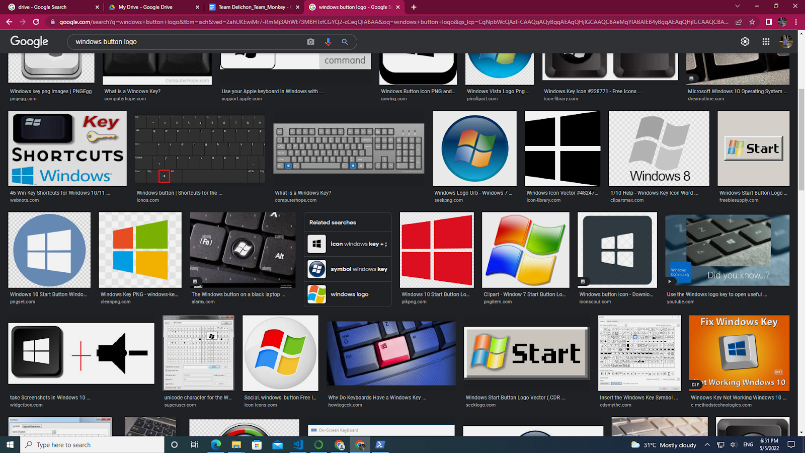 and search **Windows Powershell**. Select **Run as Administrator**

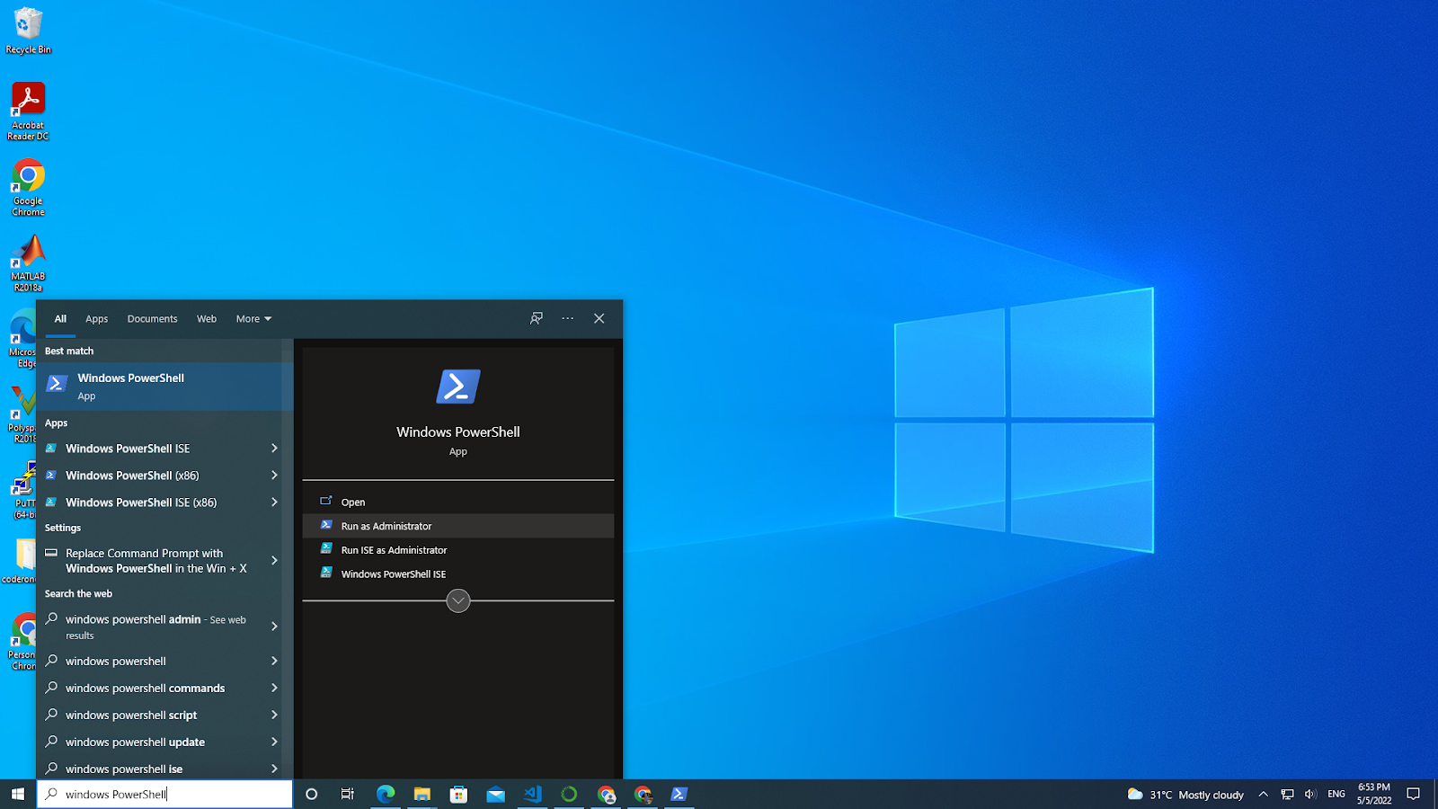

1. A powershell script will open as shown below  
   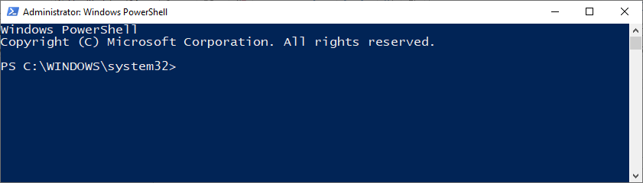
2. Enter the following list of commands as shown in the terminal. You can copy paste the commands from the text below.

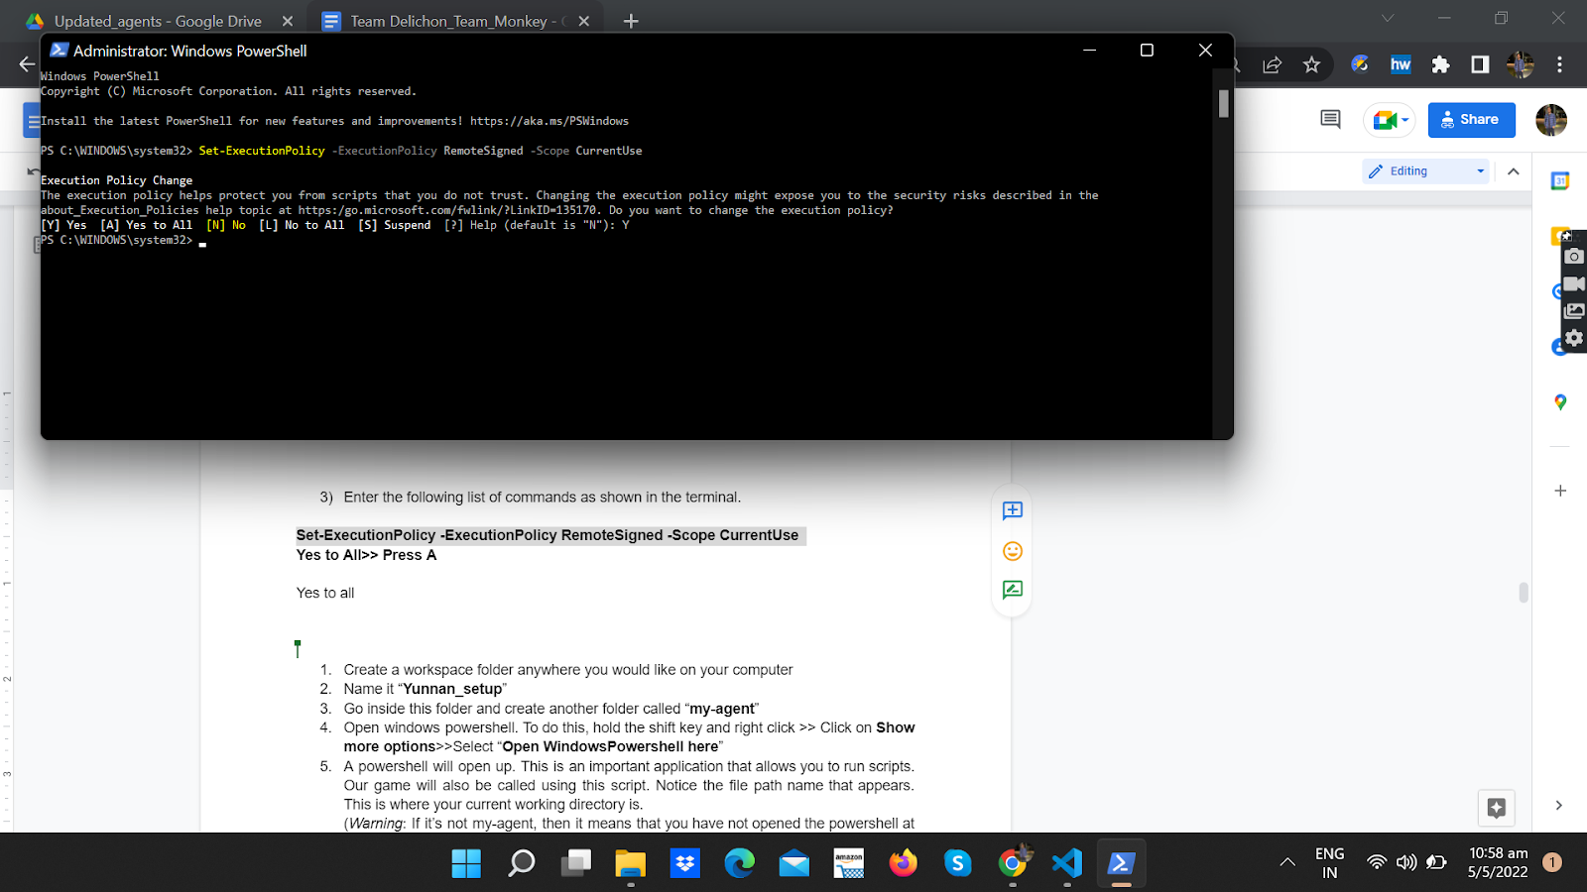

**Set-ExecutionPolicy -ExecutionPolicy RemoteSigned -Scope CurrentUse**

**Yes to All>> Press A**

#### B. Installing and setting up the background

1. Create a folder anywhere you would like on your computer. Call it **workspace**
2. Inside the folder, create a folder called **Yunnan_Setup**
3. Go inside **Yunnan_Setup** and create another folder. Call it **my**-**agent**. This is how your working directory should look like. (Note the file path order: workspace>Yunnan_setup>my_agent).   
     
   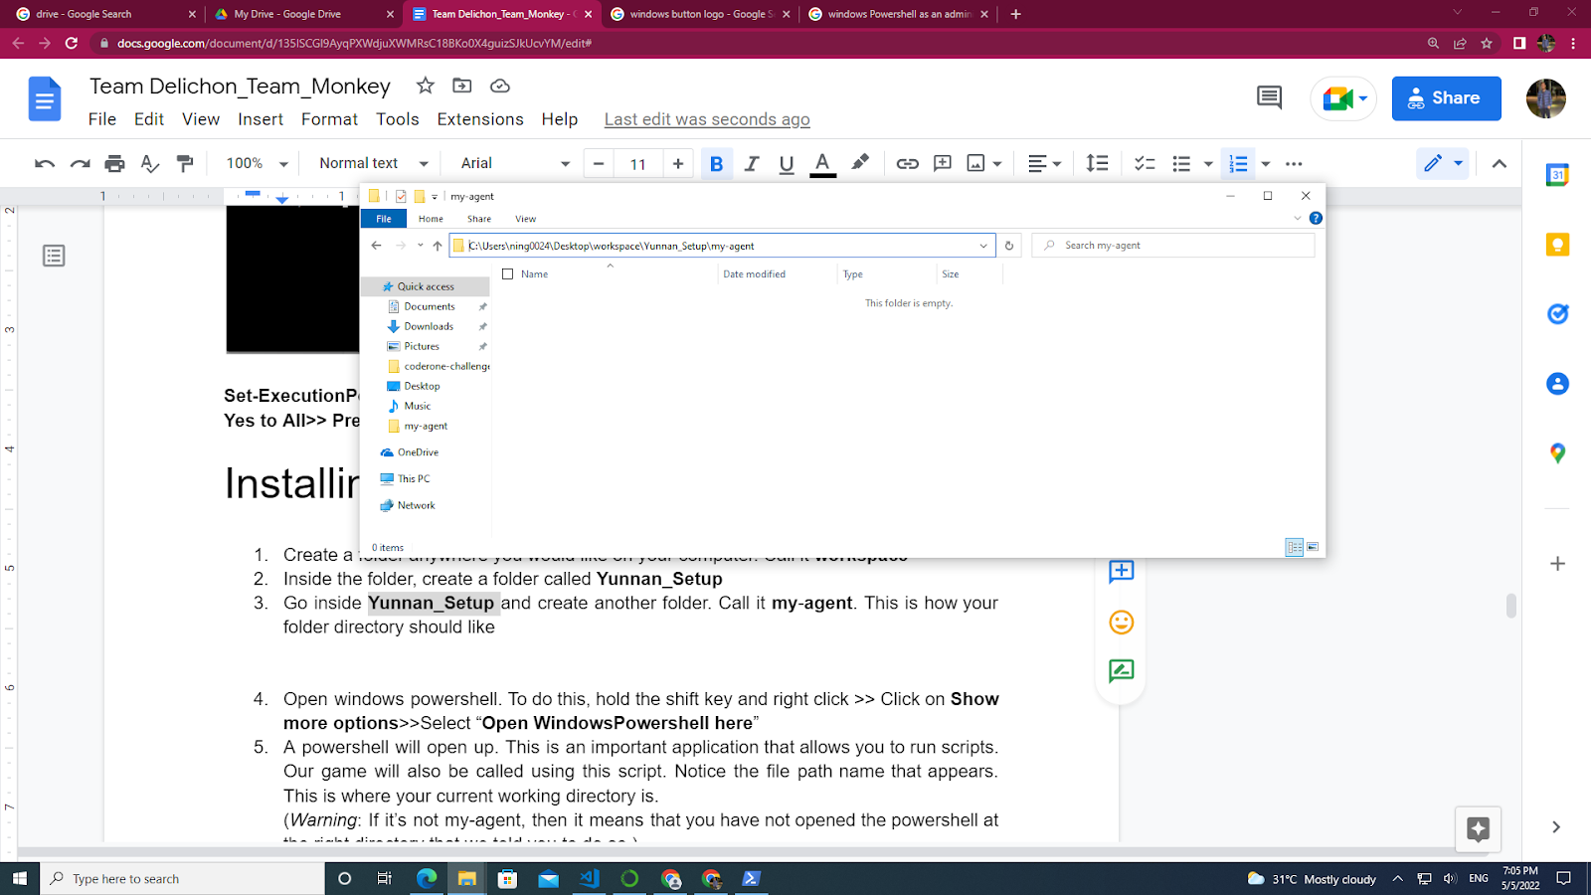
4. Open windows powershell. To do this, hold the shift key and right click >> Click on **Show more options**>>Select “**Open WindowsPowershell here**”  
   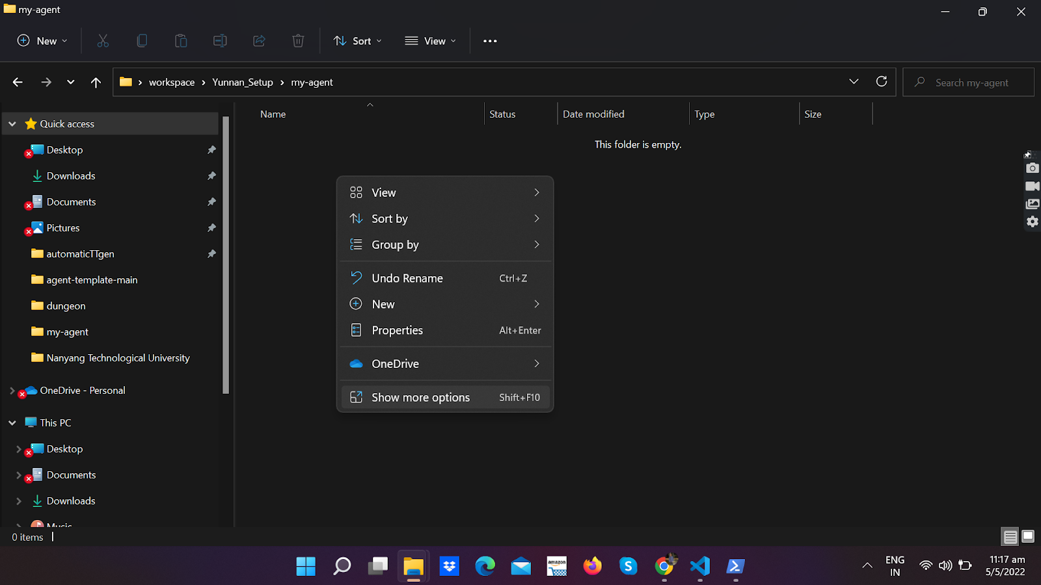  
     
   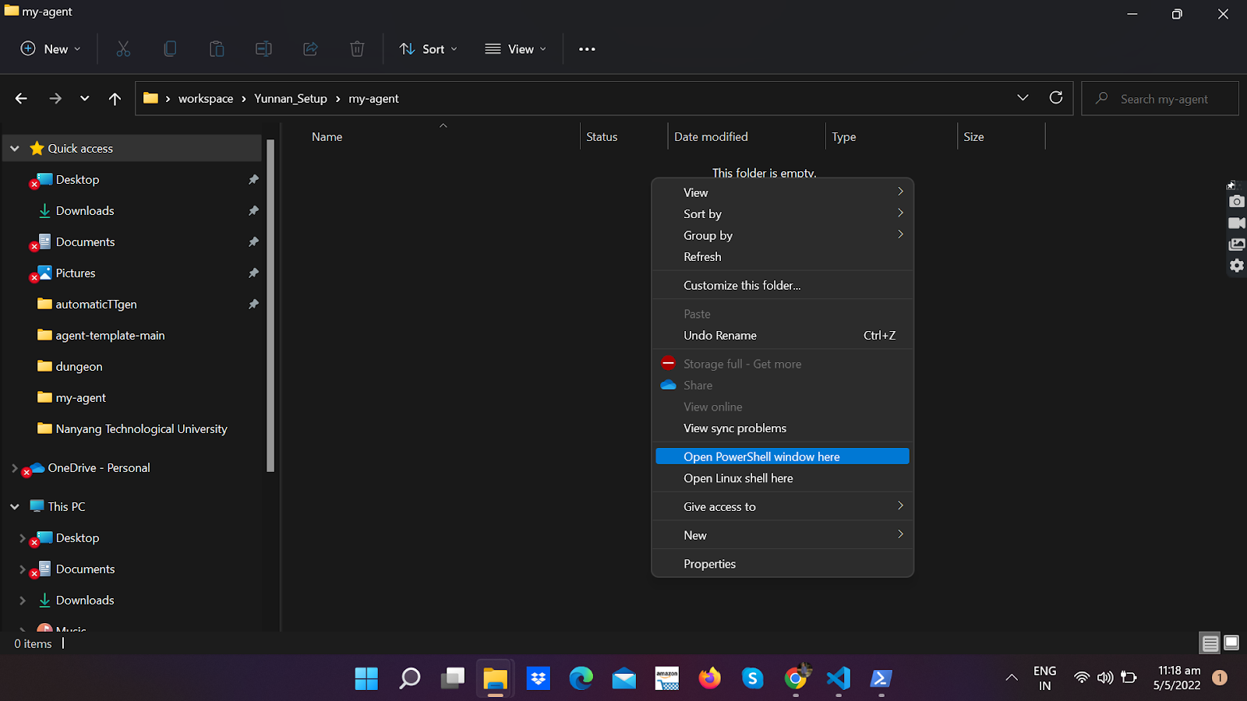
5. A powershell will open up. This is an important application that allows you to run scripts. Our game will also be called using this script. Notice the file path name that appears. This is where your current working directory is.   
     
   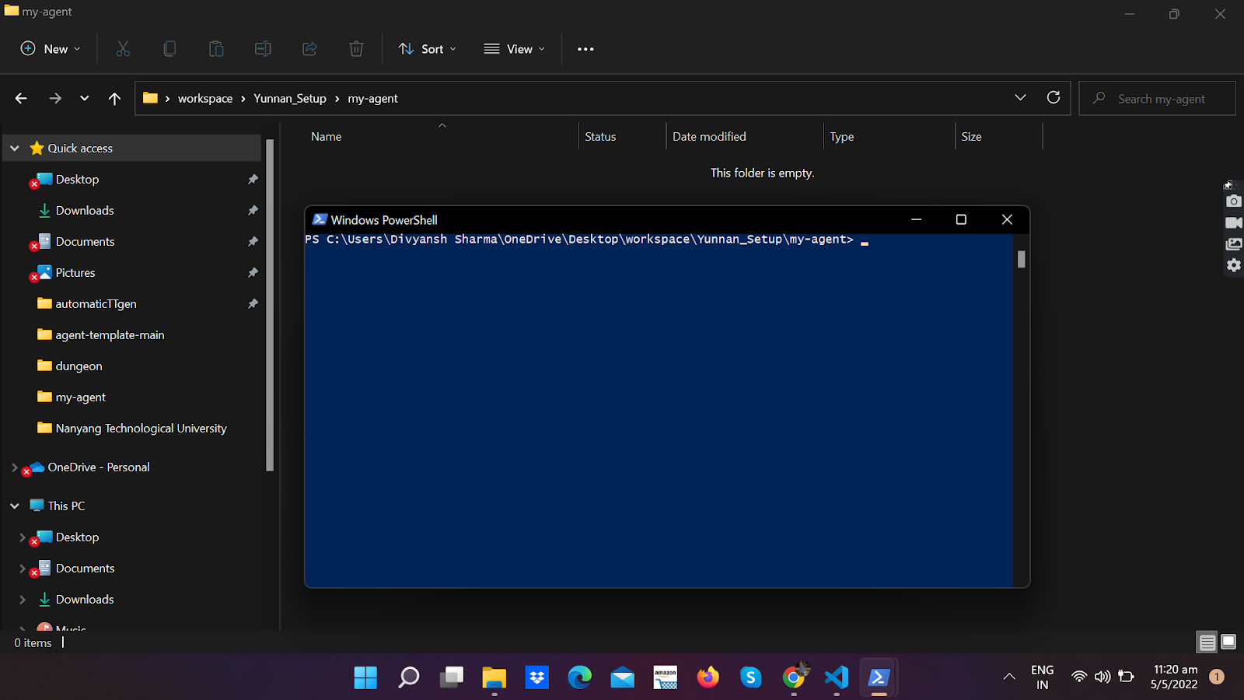  
     
   (*Warning*: If it’s not my-agent, then it means that you have not opened the powershell at the right directory that we told you to do so.)
6. Make sure you are in the my-agent directory inside the powershell. Now you need to create a virtual environment. Run the command:
7. Now create the virtual local environment using this command
8. Make a new python environment  
    **python -m venv venv**
9. Activate your virtual local environment by running

**.(space)venv/scripts/activate**

**. venv/scripts/activate**

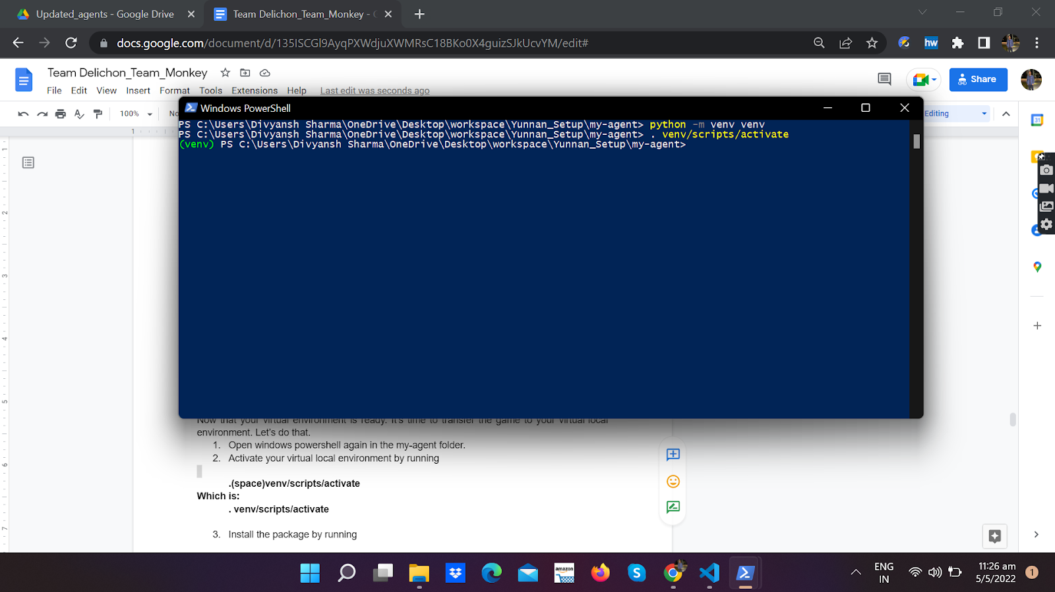

#### C. Installing the package

Now that your virtual environment is ready. It’s time to put your game in it. Let’s do that.

1. Transfer your **coderone-challenge-dungeon-0.1.6.zip** into the **my-agent** file. The contents of your my-agent file should appear as follows:  
     
   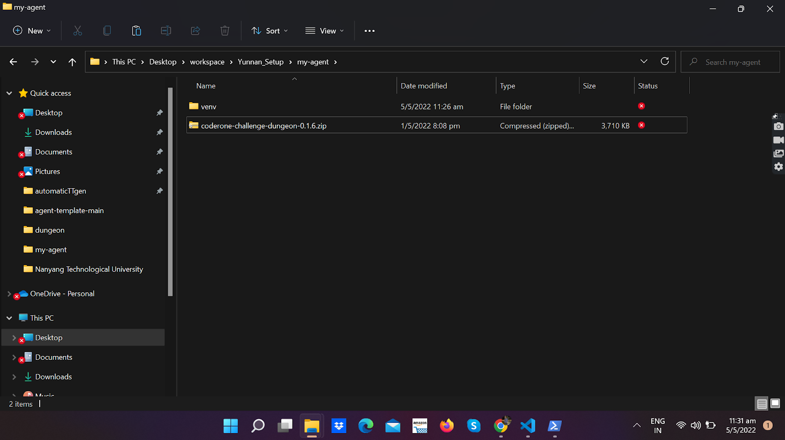
2. Go back to your powershell. Make sure your virtual environment is still activated(there should be (venv) preceding the file path). If your virtual environment is not active, or if you have reopened the powerShell, go back to step 9 and repeat. Install the package by running:

**pip install coderone-challenge-dungeon-0.1.6.zip**

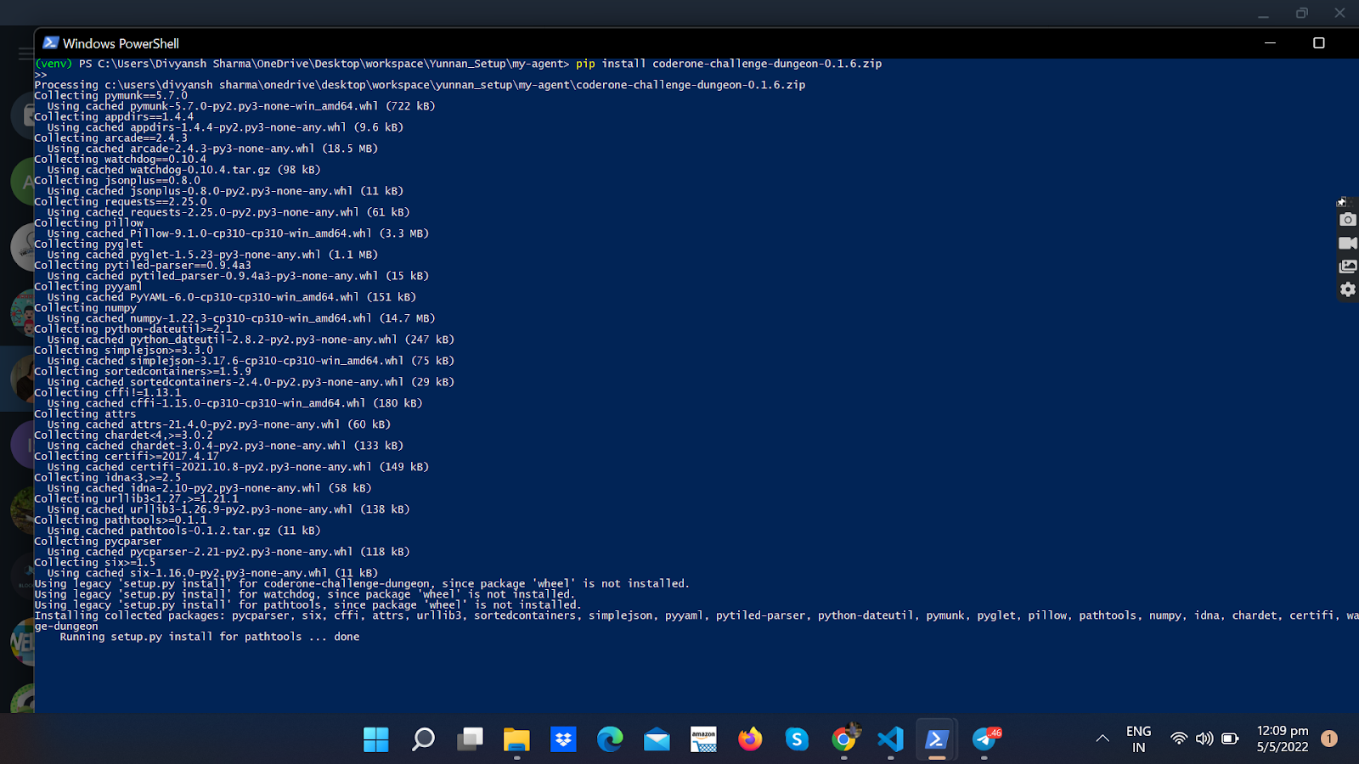

The above instruction might take some time. Do not terminate this process in the middle

1. Wow you have successfully installed and ran your environment. It’s time to execute and see this environment
2. Run the following command

coderone-dungeon --watch coderone.dungeon.agent coderone.dungeon.agent

Wow ! The game setup looks ready. Try moving your agent around. Now we are ready to code your agent

### Mac

#### A. Check if Python is installed on Mac

1. Open **Terminal** (Cmd + Space -> Type “Terminal" -> Press return)
2. Type the command python –version (double dash)
3. If Python is already installed on your Mac (which it should be) you will see this



Where 3.8.8 is the version. Your Python version should be 3.x.x.

1. If Python is NOT installed, you can download it from this page: [python.org/downloads/macos/](https://python.org/downloads/macos/)

#### B. Set up the virtual environment

1. **Create the directory** you want to install in and navigate to that place. E.g. I want to install it in ~/Documents/Ketchups/ARSC-competition

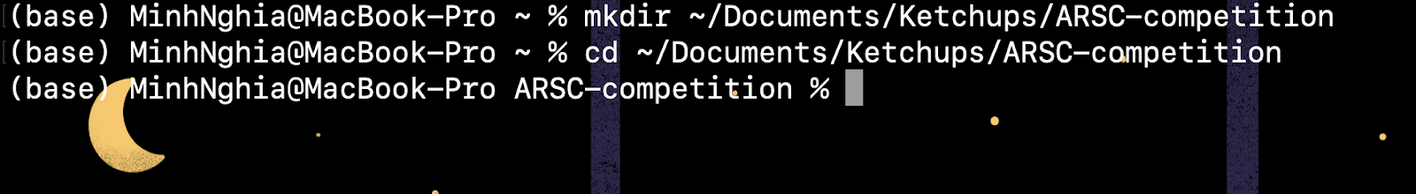

1. **Create a virtual environment** (I name it myenv, you can name it something else): Type in

python -m venv myvenv

and press Return

\**Note*: You can replace myenv in the command with your desired virtual environment name



After that, you should see a directory called ‘myenv’ (Or your environment name) inside the ARSC-competition directory.

1. **Activate the virtual environment** by typing in the command

source myenv/bin/activate

where myenv is your virtual environment name

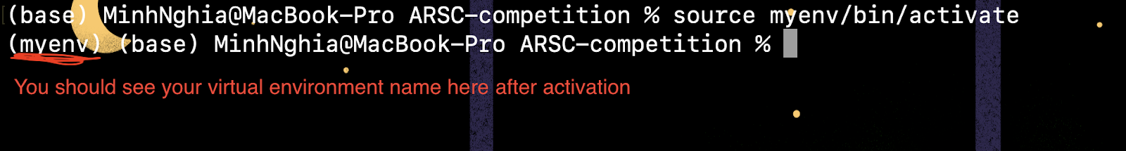

1. Install the coderone-challenge-dungeon-0.1.6.zip package

pip install <path to your .zip package>



Press Return and wait

1. To test if the installation is in place, type

coderone-dungeon --watch coderone.dungeon.agent coderone.dungeon.agent

**Note: From this point onward, i.e. the “creating an agent" and “running an agent", it is mostly the same on Mac.**

**Note 2: The ARSC-competition directory in the above example is similar to the my-agent folder in the Windows guide and the below part.**